*Laboratory Report*

**INTERNET TECHNOLOGIES LAB.**

**CAP5004L**

**School of Engineering**

**Department of Computer Science and Engineering**

|  |  |
| --- | --- |
| **Submitted By** | |
| **Student Name** | Amit |
| **Roll Number** | 180020307001 |
| **Section/Group** |  |
| **Department** | Computer Science and Engineering |
| **Session/Semester** | 2020-21/ Odd Semester |
| **Submitted To** | |
| **Faculty Name** | Ms. Manka Sharma |



**GD Goenka University**

Sohna road, Gurugram, Haryana

**Table of Content**

|  |  |  |  |
| --- | --- | --- | --- |
| Sl No | Date | Aim of the Experiment | Signature/date |
|  |  |  |  |
|  |  |  |  |
|  |  |  |  |
|  |  |  |  |
|  |  |  |  |
|  |  |  |  |
|  |  |  |  |
|  |  |  |  |
|  |  |  |  |
|  |  |  |  |

|  |  |  |
| --- | --- | --- |
| **Experiment No-1** |  | **Date:** |

**Aim of the Experiment:**

Create a document in HTML that has a paragraph of text that describes your home.

Choose at least three different phrases (3 to 6 words) of this paragraph and make them

change font, font style, color and font size when the mouse cursor is placed over them.

Each of the different phrases must change to different fonts, font styles, colors and font

sizes

**Theory (***Important functions used/ Algorithms/ Formula etc***):**

*Use consolas font (12 pt)*

**Source Code**

<!DOCTYPE html>

<html lang="en">

<head>

<meta charset="UTF-8" />

<meta name="viewport" content="width=device-width, initial-scale=1.0" />

<title>Experiment 1 - Amit Dagar</title>

<style>

body {

background-color: #f5f5f7;

font-family: "SF Pro Text", "SF Pro Icons", "Helvetica Neue",

"Helvetica", "Arial", sans-serif;

}

.col {

margin: 20px;

color: #fff;

width: 50%;

height: 100%;

padding: 30px !important;

font-style: oblique;

text-align: justify;

transition: all 0.3s ease-in-out;

box-shadow: 0 1px 2px rgba(0, 0, 0, 0.15);

overflow-y: scroll;

}

.col:hover {

box-shadow: 0 5px 15px rgba(0, 0, 0, 0.3);

transition: all 0.4s ease-in-out;

transform: scale(1.02, 1.02);

}

.col-1 {

float: left;

background: linear-gradient(135deg, #f1608a 10%, #aa68d2 100%);

}

.col-1-text:hover {

font-style: normal;

font-weight: 600;

color: #eeeeee;

font-size: large;

}

.col-2 {

float: right;

background: linear-gradient(150deg, #5d8dee 20%, #ad5fe6 90%);

}

.col-2-text:hover {

font-style: italic;

font-weight: bold;

color: #ffc;

font-size: large;

}

.col-3 {

float: left;

background: linear-gradient(150deg, #359cd7 10%, #7d6efb 100%);

}

.col-3-text:hover {

font-weight: 900;

color: #cfe;

font-size: large;

}

.card-img-top {

height: 15rem !important;

box-shadow: 0 1px 2px rgba(0, 0, 0, 0.15);

}

.text-center {

text-align: center;

}

.text-left {

text-align: left !important;

}

.rounded-lg {

border-radius: 3rem !important;

}

</style>

</head>

<body>

<div class="col col-1 rounded-lg">

<div class="text-center">

<img

src="./IMG_20200416_073204.jpg"

class="card-img-top rounded-lg"

alt=""

/>

</div>

<br />

<h2>My House</h2>

<span class="text-left"

>In this above picture is my house it has a good number of trees.It

located outside the village. This is heaven for me because its very wide

and open so we can see stars at night and in monsoon we can feel the

weather. In the morning usually anyone can listen to the charming birds. I feel

peace here and I love to live in peace.This house having 4 rooms for

living and 1 room for storage. My house have also a parking lot for

<span class="col-1-text">car, bike and tractor.</span>

</span>

</div>

<div class="col col-2 rounded-lg">

<div class="text-center">

<img

src="./WhatsApp Image 2020-08-30 at 11.11.16 AM.jpeg"

class="card-img-top rounded-lg"

alt=""

/>

</div>

<br />

<h2>My workplace</h2>

<span class="text-left">

This is my workplace as you can see in above picture here I have two

chairs and a desk with my lovely <b>MacBook Air</b> and dock station with

10 ports that powered many additional functionality to my MacBook.

Usually I work here about to

<span class="col-2-text">10-14 hours/day.</span>

</span>

</div>

<div class="col col-3 rounded-lg">

<div class="text-center">

<img

src="./IMG_20200722_113816_BURST1.jpg"

class="card-img-top rounded-lg"

alt=""

/>

</div>

<br />

<h2>View From 1<sup>st</sup> Story</h2>

<span class="text-left"

>During the rain view from its first story is awesome, as you can see in

above picture. We can see upto kms from its 1st stroy and this is

<span class="col-3-text">a good experience</span></span

>

</div>

</body>

</html>

**Output**

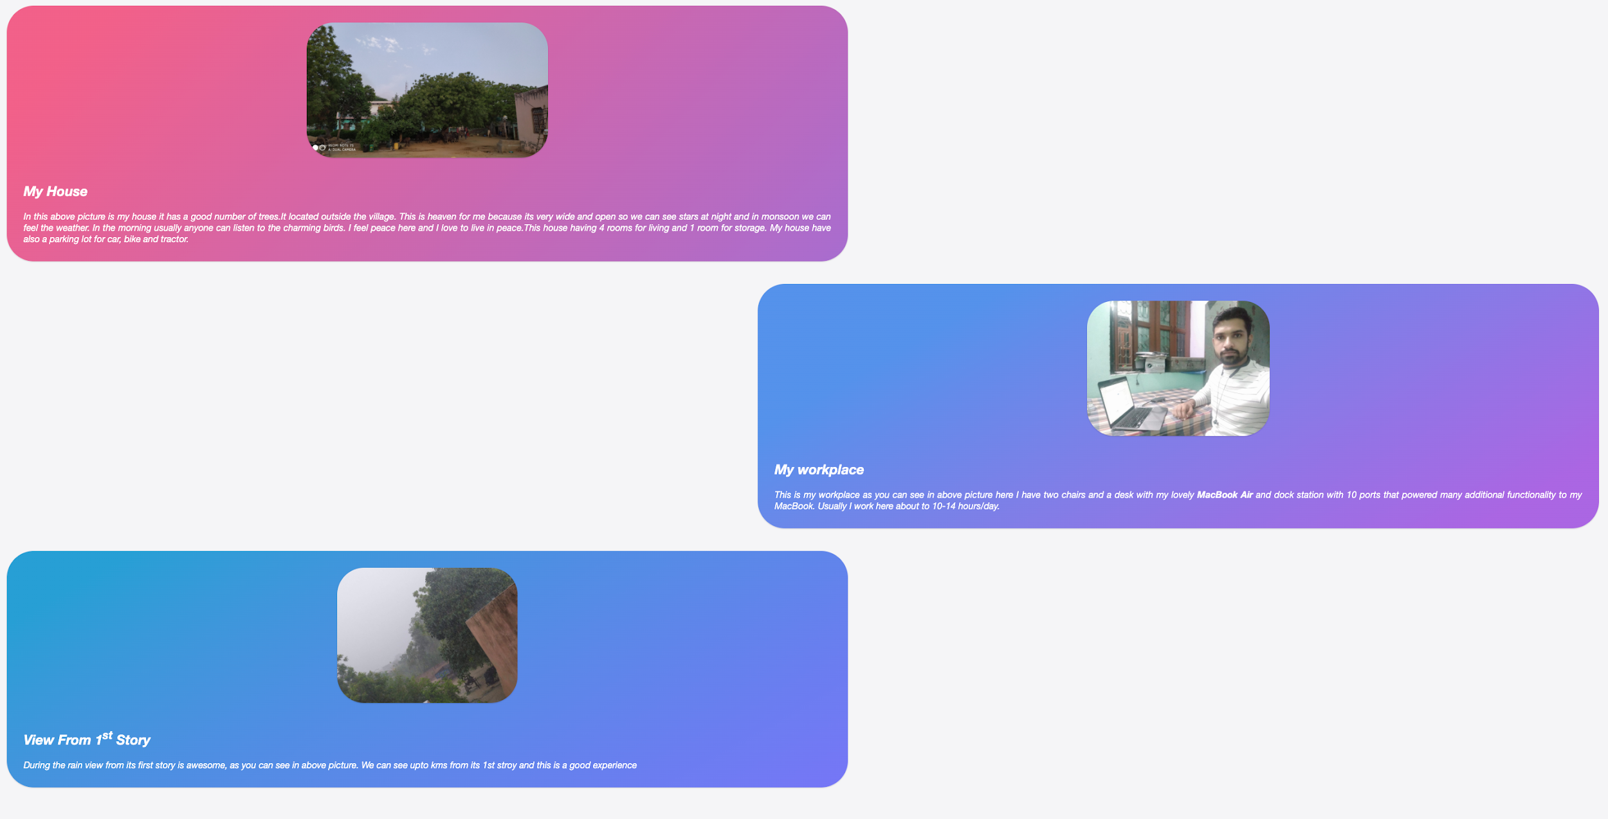

|  |  |  |
| --- | --- | --- |
| **Experiment No-1.1** |  | **Date:** |

**Aim of the Experiment:**

Using HTML and CSS, design a website as per the website address

<http://undertheweather.eu/>. A screenshot is as given below:

**Source Code**

<!DOCTYPE html>

<html lang="en-GB">

<head>

<meta charset="utf-8" />

<title>

Under the Weather | The Impact of Climate Change on Human Health

</title>

<link rel="stylesheet" href="fonts/ostrich-regular-webfont.eot" />

<style>

@font-face {

font-family: OstrichSans;

src: url("ostrich-regular-webfont.woff");

}

body {

background: #e0e0e0;

font-size: 100%;

font-family: "Libre Baskerville", serif;

font-weight: 400;

text-align: center;

justify-content: center;

}

h1 {

font-size: 6.7em;

color: #464646;

line-height: 0.879em;

margin: 0.3em 0 -0.1em 0;

font-family: "OstrichSans", "Helvetica Neue", Helvetica, Arial,

sans-serif;

font-weight: 200;

text-align: center;

}

.border {

margin-left: auto;

margin-top: 40px;

margin-right: auto;

max-width: 310px;

}

h2 {

font-style: italic;

padding: 0 10%;

font-family: "Libre Baskerville", serif;

font-weight: 400;

font-size: 1.125em;

line-height: 1.875em;

color: #464646;

text-align: center;

justify-content: center;

margin-left: auto;

margin-right: auto;

max-width: 510px;

}

.container {

margin-top: 40px;

}

.text-center {

text-align: center !important;

}

a.description {

text-decoration: underline;

color: #464646;

}

.circle {

height: 212px;

width: 212px;

display: inline-block;

border-radius: 50%;

margin-left: -15px;

opacity: 0.6;

}

.circle > a {

text-decoration: none;

color: #ffffff;

}

.circle-1 {

background: #df815a;

}

.circle-2 {

background: #e7ca52;

}

.circle-3 {

background: #7dbf94;

}

.circle-4 {

background: #639bb4;

}

.circle > a > h3 {

padding: 0.1em 10% 0;

line-height: 0.804em;

font-size: 3.5em;

font-family: "OstrichSans", "Helvetica Neue", Helvetica, Arial,

sans-serif;

font-weight: 200;

}

.circle:hover {

opacity: 1;

}

</style>

</head>

<body>

<header>

<h1>

The Impact of Climate<br />

Change on Health

</h1>

<div class="border"><hr /></div>

<h2 class="text-center">

Climate change is creating a range of new problems for public health.

The WHO &amp; WMO’s report,

<cite

><a

href="http://www.who.int/globalchange/publications/atlas/en/index.html"

target="_blank"

class="description"

>Atlas of Health &amp; Climate</a

></cite

>, highlights four main areas of emerging environmental challenges.

</h2>

</header>

<div class="border"><hr /></div>

<div class="container">

<div class="circle circle-1">

<a href="#">

<h3>

Heat Stress

</h3>

</a>

</div>

<div class="circle circle-2">

<a href="#">

<h3>

UV Radiation

</h3>

</a>

</div>

<div class="circle circle-3">

<a href="#">

<h3>

<br />

Pollans

</h3>

</a>

</div>

<div class="circle circle-4">

<a href="#">

<h3>

air pollution

</h3>

</a>

</div>

</div>

</body>

</html>

**Output**

